**Create Content Type for SharePoint 2019**

1. Go to the site where you want to create a site content type.
2. Select Settings Office 365 Settings button, and then select **Site Settings**.
3. Under **Web Designer Galleries**, select **Site content types**.

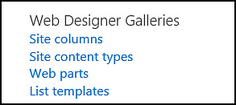

The Gallery shows all the existing site content types, grouped in categories. The one that you choose becomes the parent group of your new content type.

1. select **Create**.
2. On the **New Site Content** **Type** page, provide a name and description for the new content type.

1. Add Name
2. Description
3. In the **Parent Content Type** section, select the name of the parent group, **“Document Content Type**” and then select the **Parent Content Type** as **Document**
4. In the **Group** section, decide whether to put the new content type in an existing group, or to create a new group.
5. Create a new group “BOA group”
6. Select **OK**.

Create a word Document to make as Template

Example like below

Then Open **BOA Template** Content Type

* Advanced Settings
* Upload new document template

Then Go your library

* Library settings
* Advanced Settings
* Allow Management of content types>? Yes

Click Ok to Save it

Now you can able to see a content type section

Click Add from Existing site content types

Select your content type

Click ok

Now go to the library and able to see the template menu to create new document

Go to create new document using the template